**FINAL PROJECT REPORT**

ABOUT

**REGISTRATION AND BOOKING SYSTEM ON “WANGSAF” HOSPITAL**

**YANUAR THAIF CHALIL CANDRA**

**1I**



**POLITEKNIK NEGERI MALANG**

**DECEMBER 2022**

* 1. **Flowchart**

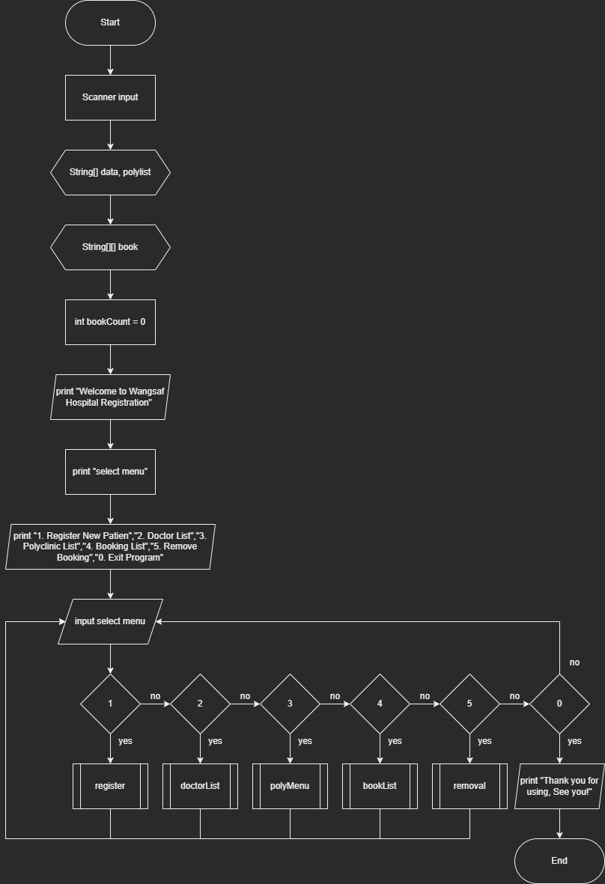

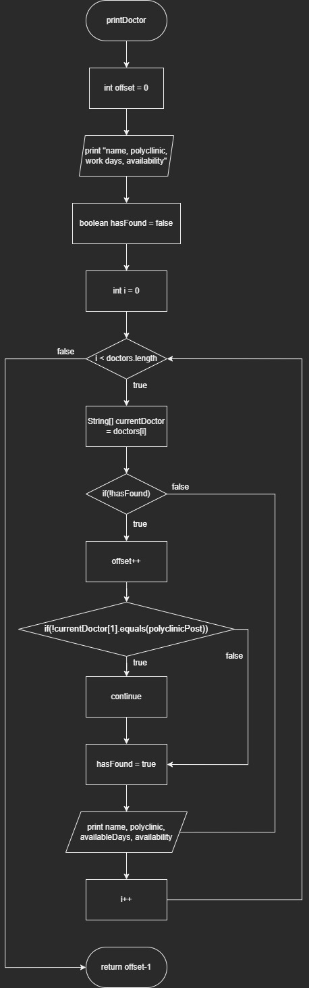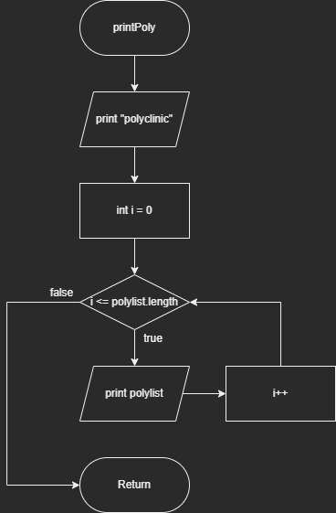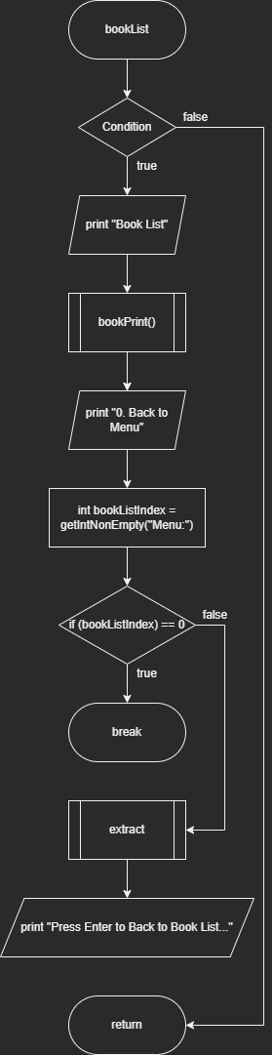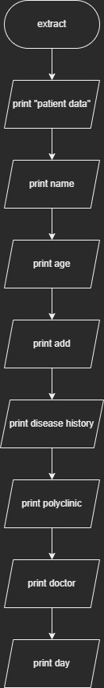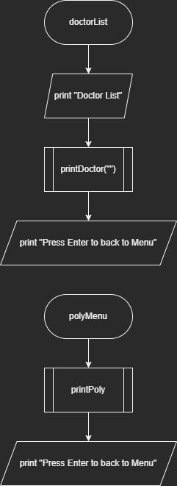

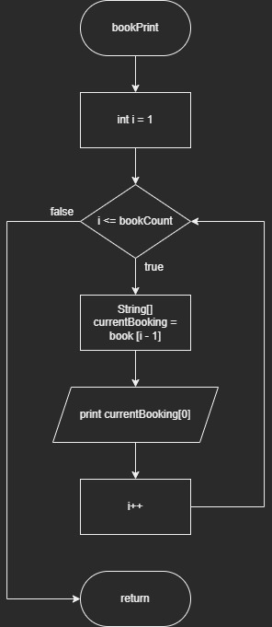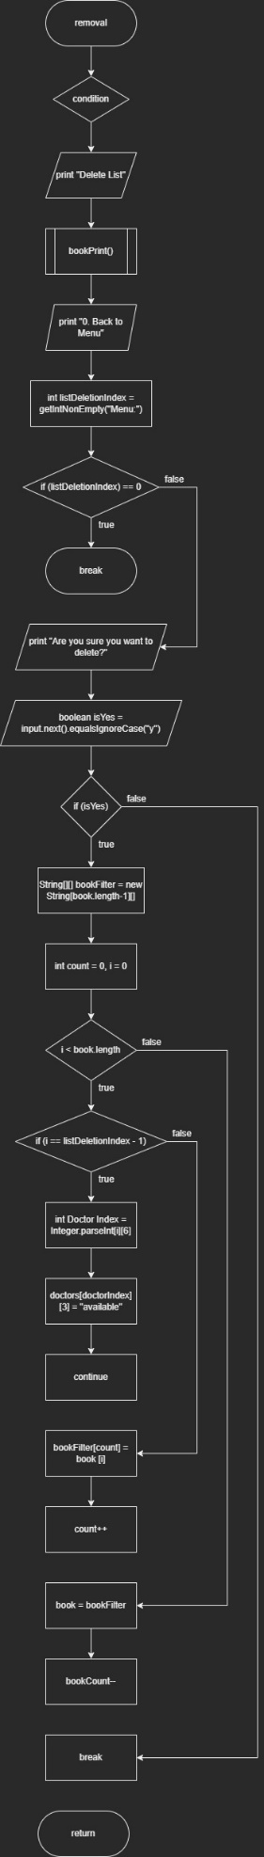

* 1. **Steps to Run the Program**

The following are the steps for running the application

1. This application consists of 6 menus, namely Register New Patient, Doctor List, Polyclinic List, Booking List, Remove Booking, and Exit Program

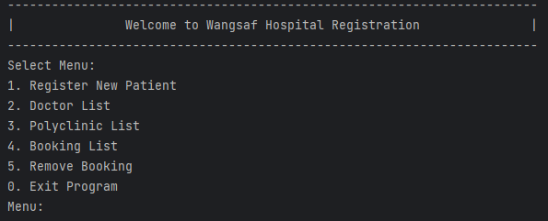

1. The first menu is Register New Patient, where we need to register all the patient data, selecting polyclinic and the doctor

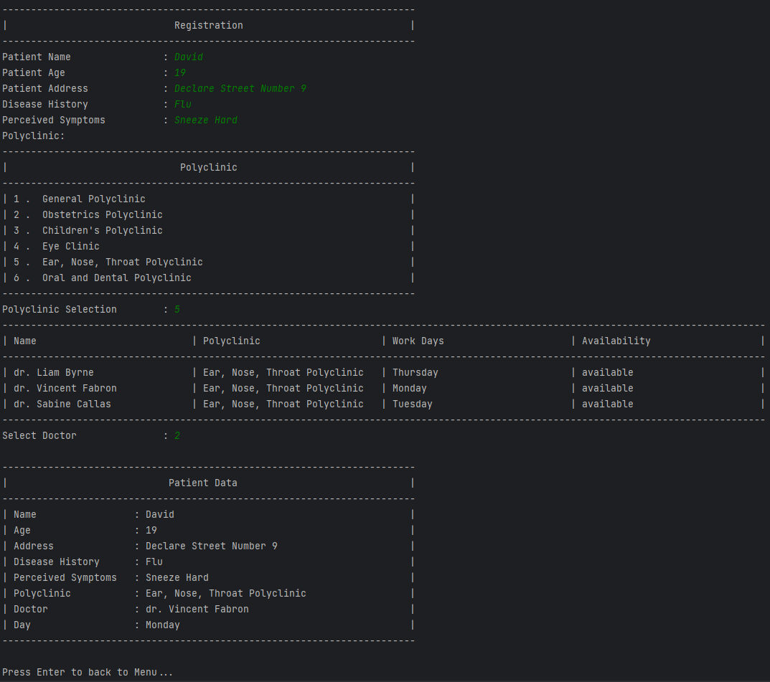

1. The second menu is consisting of the list of all Doctor, the availability will change to unavailable once we select the Doctor from the Registration menu

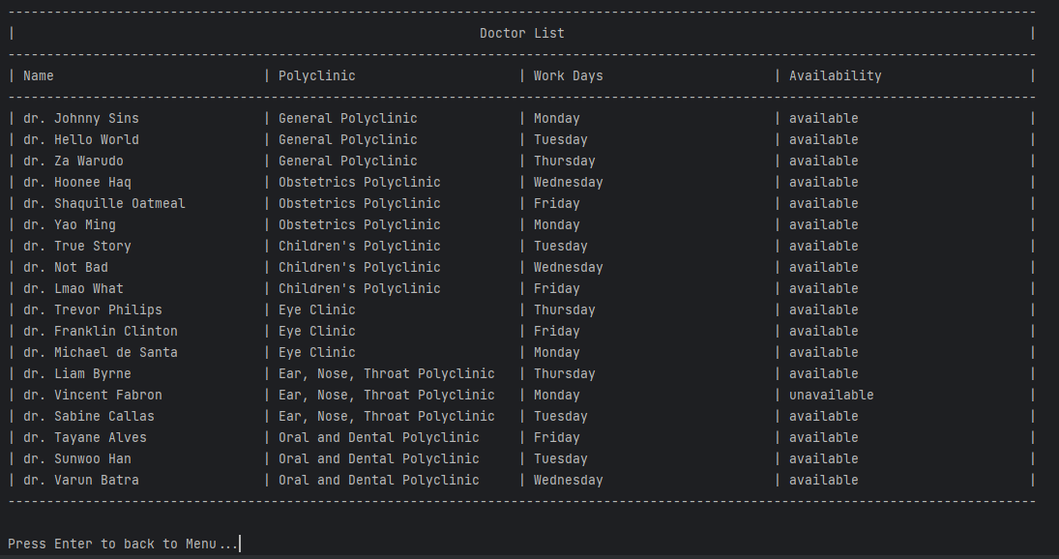

1. The third menu is showing all available Polyclinic

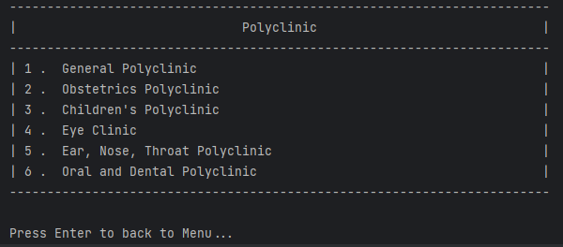

1. The fourth menu showing all the Booking list, the maximum list in the Booking is 5 patients

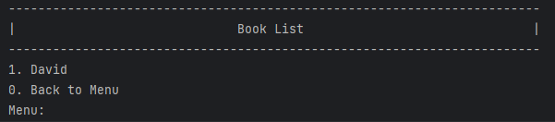

1. In the Booking list menu, we can see the patient data again by selecting the patient number in the list

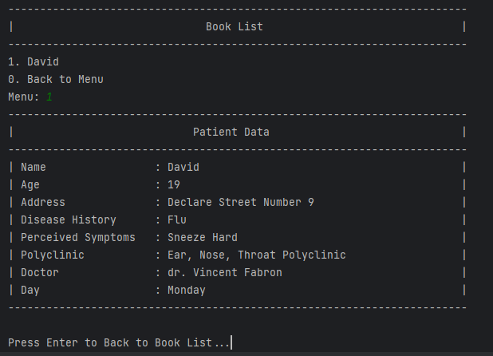

1. The Fifth menu is to delete the booking list

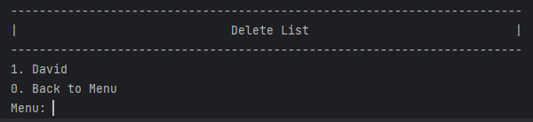

1. To delete the list, we select the number that we wanted to delete

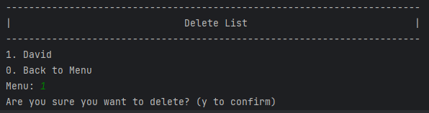

1. Once we select the number, we need to type ‘y’ or “Y” to confirm

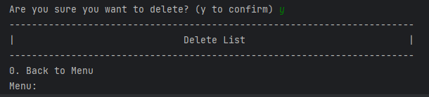

1. And the last menu is to exit the program

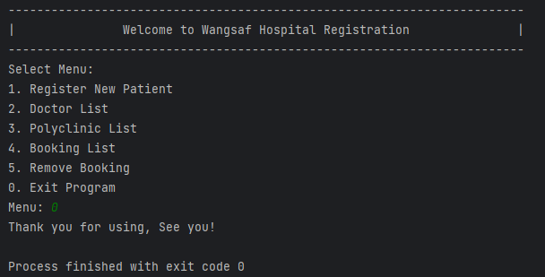

* 1. **Program Code**

import java.util.Scanner;  
public class TA  
{  
 static void text(String expression)  
 {  
 System.*out*.print(expression);  
 }  
  
 static void textln(String expression)  
 {  
 System.*out*.println(expression);  
 }  
  
 static Scanner *input* = new Scanner(System.*in*);  
 static String[] *data* = new String[9];  
 static String[] *polylist* = {"General Polyclinic", "Obstetrics Polyclinic", "Children's Polyclinic", "Eye Clinic", "Ear, Nose, Throat Polyclinic", "Oral and Dental Polyclinic"};  
 static String[][] *book* = new String[18][9];  
 static int *bookCount* = 0;  
 static String[][] *doctors* = {  
 {"dr. Johnny Sins", "0","Monday","available"},  
 {"dr. Hello World","0","Tuesday","available"},  
 {"dr. Za Warudo","0","Thursday","available"},  
 {"dr. Hoonee Haq","1","Wednesday","available"},  
 {"dr. Shaquille Oatmeal","1","Friday","available"},  
 {"dr. Yao Ming","1","Monday","available"},  
 {"dr. True Story","2","Tuesday","available"},  
 {"dr. Not Bad","2","Wednesday","available"},  
 {"dr. Lmao What","2","Friday","available"},  
 {"dr. Trevor Philips","3","Thursday","available"},  
 {"dr. Franklin Clinton","3","Friday","available"},  
 {"dr. Michael de Santa","3","Monday","available"},  
 {"dr. Liam Byrne","4","Thursday","available"},  
 {"dr. Vincent Fabron","4","Monday","available"},  
 {"dr. Sabine Callas","4","Tuesday","available"},  
 {"dr. Tayane Alves","5","Friday","available"},  
 {"dr. Sunwoo Han","5","Tuesday","available"},  
 {"dr. Varun Batra","5","Wednesday","available"}  
 };  
  
 static String getCanEmpty(String message)  
 {  
 *text*(message);  
 return *input*.nextLine();  
  
 }  
  
 static String getNonEmpty(String message, String errorMsg)  
 {  
 while (true)  
 {  
 *text*(message);  
 String userInput = *input*.nextLine();  
 if (!userInput.isEmpty()) {  
 return userInput;  
 }  
 *text*(errorMsg);  
 }  
 }  
  
 static int getIntNonEmpty(String message, String errorMsg, int min, int max)  
 {  
 while (true)  
 {  
 *text*(message);  
 int userInput = *input*.nextInt();  
 *input*.nextLine();  
 if (userInput > min && userInput < max)  
 {  
 return userInput;  
 }  
 *text*(errorMsg);  
 }  
 }  
  
 public static void printPoly()  
 {  
 *textln*("------------------------------------------------------------------------");  
 System.*out*.printf("| %28s %s %-28s |\n", " ", "Polyclinic", " ");  
 *textln*("------------------------------------------------------------------------");  
 for (int i = 1; i <= *polylist*.length; i++)  
 {  
 System.*out*.printf("| %d %s %-63s |\n", i, ". ", *polylist*[i - 1]);  
 }  
 *textln*("------------------------------------------------------------------------");  
 }  
  
 public static void polyMenu()  
 {  
 *printPoly*();  
 *text*("\nPress Enter to back to Menu...");  
 *input*.nextLine();  
 }  
  
 private static void bookPrint()  
 {  
 for (int i = 1; i <= *bookCount*; i++)  
 {  
 String[] currentBooking = *book*[i - 1];  
 System.*out*.printf("%d. %s\n", i, currentBooking[0]);  
 }  
 }  
  
 static int printDoctor(String polyclinicPost)  
 {  
 int offset = 0;  
 *textln*("-------------------------------------------------------------------------------------------------------------------------------------");  
 System.*out*.printf("| %-30s | %-30s | %-30s | %-30s |\n", "Name", "Polyclinic", "Work Days","Availability");  
 *textln*("-------------------------------------------------------------------------------------------------------------------------------------");  
 boolean hasFound = false;  
 for (int i = 0; i < *doctors*.length; i++)  
 {  
 String[] currentDoctor = *doctors*[i];  
 if (!polyclinicPost.isEmpty())  
 {  
 if(!hasFound) offset++;  
 //ngga match  
 if(!currentDoctor[1].equals(polyclinicPost))  
 {  
 continue;  
 }  
 hasFound = true;  
 }  
 String name = currentDoctor[0];  
 String polyclinic = *polylist*[Integer.*parseInt*(currentDoctor[1])];  
 String availableDays = currentDoctor[2];  
 String availability = currentDoctor[3];  
  
 System.*out*.printf("| %-30s | %-30s | %-30s | %-30s |\n", name, polyclinic, availableDays, availability);  
 }  
 *textln*("-------------------------------------------------------------------------------------------------------------------------------------");  
 return offset-1;  
 }  
  
 private static void register()  
 {  
 if (*bookCount* > 4)  
 {  
 *textln*("");  
 *textln*("The booking has reached limit! (5 book)");  
 }  
 else  
 {  
 *textln*("------------------------------------------------------------------------");  
 *textln*("| Registration |");  
 *textln*("------------------------------------------------------------------------");  
 *data*[0] = *getNonEmpty*("Patient Name\t\t\t\t: ", "Patient Name can't be Empty!\n");  
 *data*[1] = String.*format*("%d", *getIntNonEmpty*("Patient Age\t\t\t\t\t: ", "Patient Age can't be below 0 and beyond 200!\n", 0, 201));  
 *data*[2] = *getNonEmpty*("Patient Address\t\t\t\t: ", "Patient Address can't be Empty!\n");  
 *data*[3] = *getCanEmpty*("Disease History\t\t\t\t: ");  
 *data*[4] = *getNonEmpty*("Perceived Symptoms\t\t\t: ", "Perceived Symptoms can't be Empty!\n");  
 *textln*("Polyclinic: ");  
 *printPoly*();  
 *data*[5] = String.*format*("%d", *getIntNonEmpty*("Polyclinic Selection\t\t: ", "Please select Polyclinic Correctly!\n", 0, *polylist*.length + 1));  
 int polyclinicIndex = Integer.*parseInt*(*data*[5]) - 1;  
 String polyclinic = *polylist*[polyclinicIndex];  
 int offset = *printDoctor*(String.*format*("%d", polyclinicIndex));  
 String doctorName;  
 String availableDays;  
 while (true)  
 {  
 *data*[6] = String.*format*("%d", *getIntNonEmpty*("Select Doctor\t\t\t\t: ", "Please Select Doctor Correctly!\n", 0, 4) - 1 + offset);  
 int doctorIndex = Integer.*parseInt*(*data*[6]);  
 String[] doctor = *doctors*[doctorIndex];  
 doctorName = doctor[0];  
 availableDays = doctor[2];  
 boolean isDoctorAvailable = doctor[3].equals("available");  
 doctor[3] = "unavailable";  
 if (isDoctorAvailable) break;  
 *textln*("Doctor isn't available right now, please choose another Doctor!");  
 *data*[6] = null;  
 }  
 *textln*("");  
 *extract*(*data*[0], *data*[1], *data*[2], *data*[3], *data*[4], polyclinic, doctorName, availableDays);  
 *book*[*bookCount*][0] = *data*[0];  
 *book*[*bookCount*][1] = *data*[1];  
 *book*[*bookCount*][2] = *data*[2];  
 *book*[*bookCount*][3] = *data*[3];  
 *book*[*bookCount*][4] = *data*[4];  
 *book*[*bookCount*][5] = *data*[5];  
 *book*[*bookCount*][6] = *data*[6];  
 *book*[*bookCount*][7] = *data*[7];  
 *bookCount*++;  
 *textln*("");  
 *text*("Press Enter to back to Menu...");  
 *input*.nextLine();  
 }  
 }  
  
 private static void booklist()  
 {  
 do  
 {  
 *textln*("------------------------------------------------------------------------");  
 *textln*("| Book List |");  
 *textln*("------------------------------------------------------------------------");  
 *bookPrint*();  
 *textln*("0. Back to Menu ");  
 int bookListIndex = *getIntNonEmpty*("Menu: ", "Please choose menu correctly!\n", -1, *bookCount*+1);  
 if (bookListIndex == 0)  
 {  
 break;  
 }  
 String[] bookSelect = *book*[bookListIndex - 1];  
 int polyclinicIndex = Integer.*parseInt*(bookSelect[5]);  
 String polyclinic = *polylist*[polyclinicIndex - 1];  
 int doctorIndex = Integer.*parseInt*(bookSelect[6]);  
 String doctor = *doctors*[doctorIndex][0];  
 String daySelection = *doctors*[doctorIndex][2];  
 *extract*(bookSelect[0], bookSelect[1], bookSelect[2], bookSelect[3], bookSelect[4], polyclinic, doctor, daySelection);  
 *textln*("");  
 *text*("Press Enter to Back to Book List...");  
 *input*.nextLine();  
 }  
 while (true);  
 }  
  
 private static void removal()  
 {  
 do  
 {  
 *textln*("------------------------------------------------------------------------");  
 *textln*("| Delete List |");  
 *textln*("------------------------------------------------------------------------");  
 *bookPrint*();  
 *textln*("0. Back to Menu ");  
 int listDeletionIndex = *getIntNonEmpty*("Menu: ", "Please choose menu correctly!\n", -1, *bookCount*+1);  
 if (listDeletionIndex == 0)  
 {  
 break;  
 }  
  
 *text*("Are you sure you want to delete? (y to confirm) ");  
 boolean isYes = *input*.next().equalsIgnoreCase("y");  
  
 if (isYes)  
 {  
 String[][] bookFilter = new String[*book*.length-1][];  
 int count = 0;  
 for (int i = 0; i < *book*.length; i++)  
 {  
 if (i == listDeletionIndex - 1) {  
 int doctorIndex = Integer.*parseInt*(*book*[i][6]);  
 *doctors*[doctorIndex][3] = "available";  
 continue;  
 }  
 bookFilter[count] = *book*[i];  
 count++;  
 }  
 *book* = bookFilter;  
 *bookCount*--;  
 }  
 }  
 while(true);  
 }  
  
 public static void extract(String name, String age, String add, String dis, String sym, String poly, String doc, String day)  
 {  
 *textln*("------------------------------------------------------------------------");  
 *textln*("| Patient Data |");  
 *textln*("------------------------------------------------------------------------");  
 System.*out*.printf("| %-20s : %-45s |\n","Name",name);  
 System.*out*.printf("| %-20s : %-45s |\n", "Age",age);  
 System.*out*.printf("| %-20s : %-45s |\n", "Address",add);  
 System.*out*.printf("| %-20s : %-45s |\n", "Disease History",dis);  
 System.*out*.printf("| %-20s : %-45s |\n", "Perceived Symptoms",sym);  
 System.*out*.printf("| %-20s : %-45s |\n", "Polyclinic",poly);  
 System.*out*.printf("| %-20s : %-45s |\n", "Doctor",doc);  
 System.*out*.printf("| %-20s : %-45s |\n", "Day",day);  
 *textln*("------------------------------------------------------------------------");  
 }  
  
 private static void doctorsList()  
 {  
 *textln*("-------------------------------------------------------------------------------------------------------------------------------------");  
 System.*out*.printf("| %-58s %11s %58s |\n"," ","Doctor List"," ");  
 *printDoctor*("");  
 *textln*("");  
 *text*("Press Enter to back to Menu...");  
 *input*.nextLine();  
 }  
  
 public static void main(String[] args) {  
 int menu;  
 do  
 {  
 *textln*("------------------------------------------------------------------------");  
 *textln*("| Welcome to Wangsaf Hospital Registration |");  
 *textln*("------------------------------------------------------------------------");  
 *textln*("Select Menu:");  
 *textln*("1. Register New Patient");  
 *textln*("2. Doctor List");  
 *textln*("3. Polyclinic List");  
 *textln*("4. Booking List");  
 *textln*("5. Remove Booking");  
 *textln*("0. Exit Program");  
 menu = *getIntNonEmpty*("Menu: ", "Please choose menu correctly!\n", -1, 6);  
 switch (menu) {  
 case 1:  
 *register*();  
 break;  
 case 2:  
 *doctorsList*();  
 break;  
 case 3:  
 *polyMenu*();  
 break;  
 case 4:  
 *booklist*();  
 break;  
 case 5:  
 *removal*();  
 break;  
 case 0:  
 *textln*("Thank you for using, See you!");  
 break;  
 }  
 }  
 while (menu != 0);  
 }  
}